**1-5th April 2014**

**Five Days in the Himalayas with lovely people, thoughts and non-fiction film.**

**[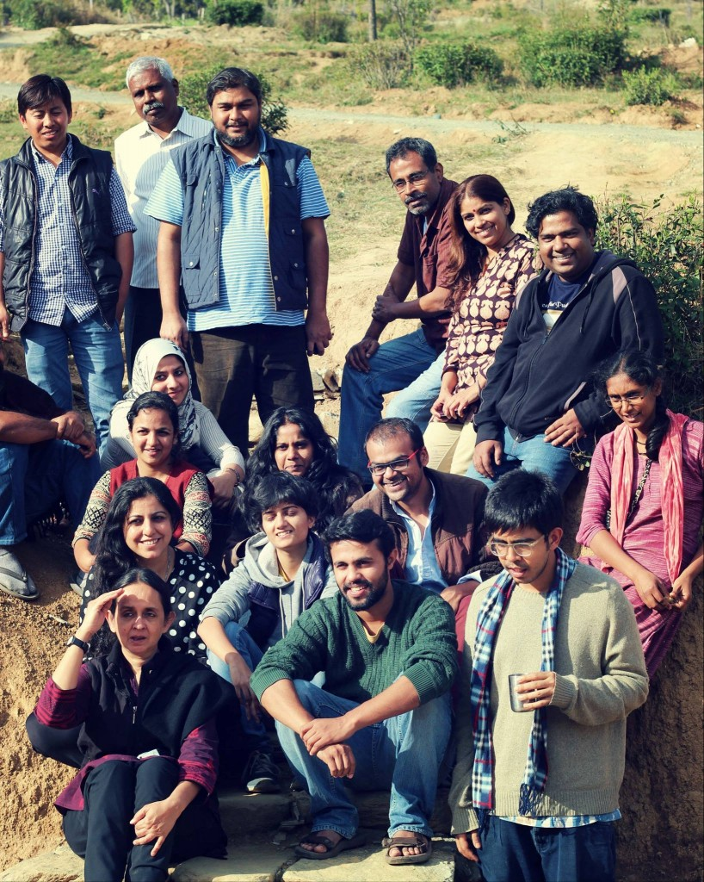](http://www.sambhaavnaa.org/wp-content/uploads/2014/02/906752_10201584387633832_5150076673161004202_o.jpg)**

**What is Docu Charcha**Docu Charcha is a space for discussion on different aspects of the making of a non-fiction film: language of film making, ethics of documentary storytelling, the historic spaces occupied by documentary films, current channels of distribution and funding and the relevance of documentary today.

Along with discussions, emphasis is laid on non-hierarchical co-mentoring, often neglected in competitive pitching forums. Participants have a chance to show their own work (at any stage of development), and gain focused inputs on their work from filmmakers.

We believe that a spirited and supportive community helps filmmakers reach out and call upon each other through informal networks. It makes the sharing of thoughts and skills between filmmakers of varied backgrounds, a possibility. This exchange of diverse experience is the crux of learning at Docu Charcha.

**The first Docu Charcha**The first Docu Charcha took place between April 1st and 5th 2014. There were seventeen participants and five resource people between whom discussions and ideas were exchanged. The workshop was held at Sambhaavnaa Institute, built and designed to foster connections and conversations. We found that due to the design of the space and people at Sambhaavnaa, an informal learning community was possible during the one week at Docu Charcha.

**The Genesis and What it Became**The genesis of Docu Charcha was a serendipitous merging of needs. Three documentary making friends in Delhi realized that they were all craving a space to discuss the medium and work on it as a community. As they approached Sambhaavnaa Institute, who was keen to host the workshop, the idea took shape. Resource people such as RV Ramani, Rahul Roy, Saba Devan, Sameera Jain and Peter Sutoris were gracious with their time and ideas. Participants came together with an open mind and eagerness to learn from one another.

Several ideas and hopes led to Docu Charcha, a workshop that came about to address the needs of filmmakers working on non-fiction audio visual projects in isolated pockets across the country.

On an individual level some of us felt that our work needed a larger community of support and interaction. As we planned the sessions for Docu Charcha, we found many themes that needed discussions. The workshop was envisioned as a collaborative space for diverse practitioners and enthusiasts of documentary in an inclusive and collaborative environment.

As the attendeesdiscussed different themes regarding the practice during the workshop, they began to discover points of consensus and disagreement.

The setting and time spent together allowed participants to come together to deeply introspect on the medium that we have adopted.

We began to trace the roots of our choices in filmmaking to see how they inform their work. We began to try and identify the elements in our work that are uniquely ours and others that we want to include in our work.

We discussed the larger responsibility of depiction that we had wanted, to try and understand the nuances of what we have selected as a medium.

The stories that filmmakers tell in most cases, expressed participants, related to the themes they are searching for, themes that have a direct bearing and a definite reflection on who they are as people and what concerns they have grown up to have. This part of our Docu Charcha was liberating in its capacity to connect the personal and the expression in ways that only a certain type of rigorous and inclusive exchange of ideas can foster. We feel that this is at the crux of our learning and a very important direction, something that most of us are in search of. The ideas exist, but the way and when they get articulated has a much to do with interaction with others dealing with similar questions. We hope that some amount of clarity was at sight for everyone present as a result of this exercise in engagement.

**Discussions at Docu Charcha 2014**

The discussions at ‘Docu Charcha’ were honest, supportive, and constructive. This allowed people to openly challenge one another and themselves to different concepts of film making.

One important discussion that took place was centered on the age old question of what is most important when making a film, whether it is the subject, the story, or the craft.

Indian documentary films were initially fostered by development funding and agendas, thus many of the early films were of what is today called an “activist” bent. Today, “activist” filmmaking has become synonymous with a practice of the craft that is not rigorous. Films that do not follow the ethics, theory and craft of filmmaking are seen as “activist” films, especially by funders.

At the heart of this was another debate. Parallel to an understanding of filmmaking, that has the filmmaker at the centre, is the one with the film at the centre, and what it depicts and who it represents.

Through conversations and analysis, many harsh truths revealed themselves. One of them being that one of the most damaging things a filmmaker can do in the process of representation is to suppress the voice of the entity he/she is depicting. It became clear that in the course of making a film, without constant vigil, this can happen to the most well-meaning and sensitive of filmmaker’s.

**What is the nature of an empowered representation?** It was felt that there is no one set of rules to achieve it, but that the respect between the filmmaker, the people in the film and the stories or issues being depicted never go unmissed by the audience, even if the filmmaker themselves were unaware of the magnitude of their thought.

Another theme that emerged from this discussion was the nature of aesthetics in filmmaking, and how aesthetics affect the film, in addition to being pleasing to the eye, aesthetics play a role in conveying the feelings and themes of a film.

Another important discussion revolved around the role of the Producer. Paul Pauwels pointed out that a ‘Producer’ in the European context is often the person who undertakes the production (administration) of the film, but does not provide the financing of the film. In India, however, financers often call themselves producers, even though they do not work on the production of the film. Thus, some of the participants raised the idea of a petition that they could float to demand that Indian film financers call themselves “Commissioning Editors” and not producers, unless they plan to provide production support.

[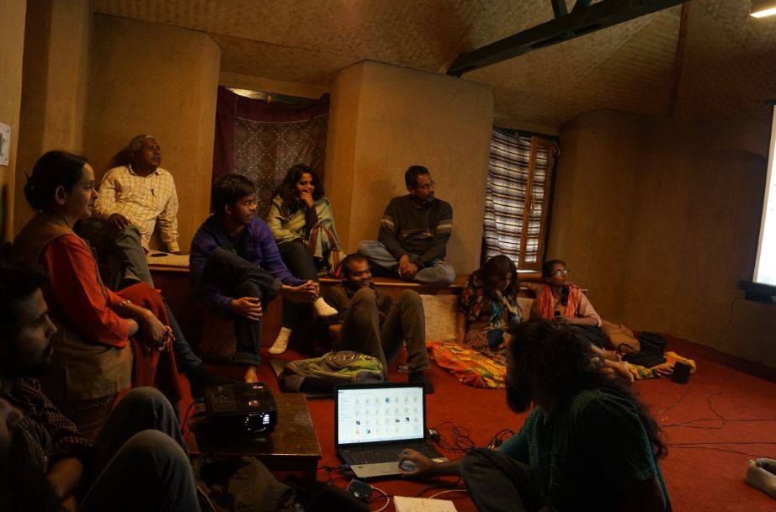](http://www.sambhaavnaa.org/wp-content/uploads/2014/02/1471752_10203552584284020_3394686467941660751_n.jpg)

**Pen and Seed Story**

[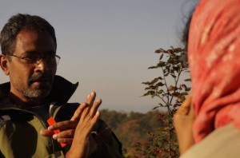](http://www.sambhaavnaa.org/wp-content/uploads/2014/02/1002681_10203552581563952_2211679930897732989_n1.jpg)

Many of the discussions we had, underlined the idea that camera work and editing will be incomplete if they are approached merely as tools to tell a story. A more nuanced approach demands looking upon visualization and editing as stories on their own.

For instance, one of the participants at Docu Charcha explained that she approaches filmmaking from a utilitarian perspective. Her unique and in many ways awe-inspiring story is one of a seed activist who has, against all odds, adopted filmmaking as a mode of expression to promote her love for and dedication towards seeds and a strong environmental ethic.

How this participant chanced upon filmmaking made for a serendipitous and inspiring story. While some were basking in the idea of the medium that is now at a point in history where so many diverse people can access it, and make it their own, she had a very un-romantic approach to the whole matter. She had very little attachment to the medium itself. In fact, she was uncomfortable with a 21st century approach to technology. She was simply using the medium of film within a temporary time frame, to serve her purpose of seed conservation.

At the same time, she had come to Docu Charcha to understand and learn better filmmaking within the utilitarian framework that she had placed it in. She felt that she had no attachment to the medium, but wanted to understand how to make better films.

A lot of the conversation at Docu Charcha seemed to indicate that one can only better their practice of filmmaking through perceiving and developing some concern and attachment to the medium.

One of the facilitators threw a plastic pen on the floor and asked her to imagine a seed next to it. He said that the way she would shoot the pen and the seed would and should be different, because the participant loves the seed and not the pen. He elaborated that the emotion needs to reflect in her images of the seed and that this would be the path to better filmmaking. To inherit and stimulate emotions in every image so the audience can connect, is the path to better filmmaking.

**Moments and Surprises**

While there were some challenges, Docu Charcha offered myriad surprises and moments that really stand out. Some of the important elements that came out of Docu Charcha, especially those that came as a complete surprise, are important to put down for memory.

While at the beginning of the week the participants and resource persons were sometimes apprehensive about the interactions they were having, as the days went on, one saw strong bonds forming, and a rigorous sharing taking place. Unlikely bonds, likely bonds and sharing across opinions took place.

[](http://www.sambhaavnaa.org/wp-content/uploads/2014/02/998972_10202362649400890_7095863585305976572_n.jpg)

RV Ramani, a resource person who was there all week, not only spent all his time in sessions but also offered early morning sessions with the camera, and had large groups of participants asking him questions and conducting exercises even after the workshop was officially “over.”

[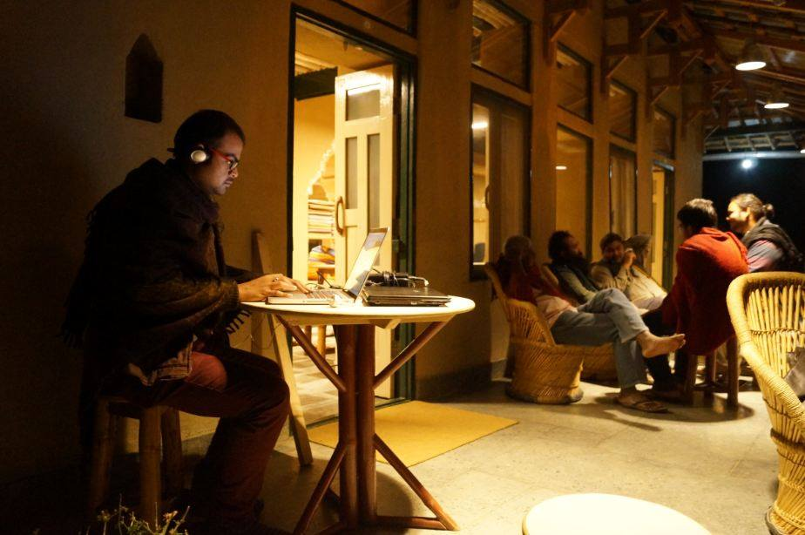](http://www.sambhaavnaa.org/wp-content/uploads/2014/02/10264956_10203552571403698_3910816877025035516_n.jpg)

 Several participants brought ongoing projects for mentorship and used the little time outside sessions at Docu Charcha to re-edit and work on their trailers before they were shown for discussion. Time stretched beyond limits as screenings went on till late at night, and participants woke up earlier and earlier to begin their day.

In addition to the impromptu sessions and stretched time, participants and resource people formed relationships with Sambhaavnaa Institute locals and spent significant time with them.

[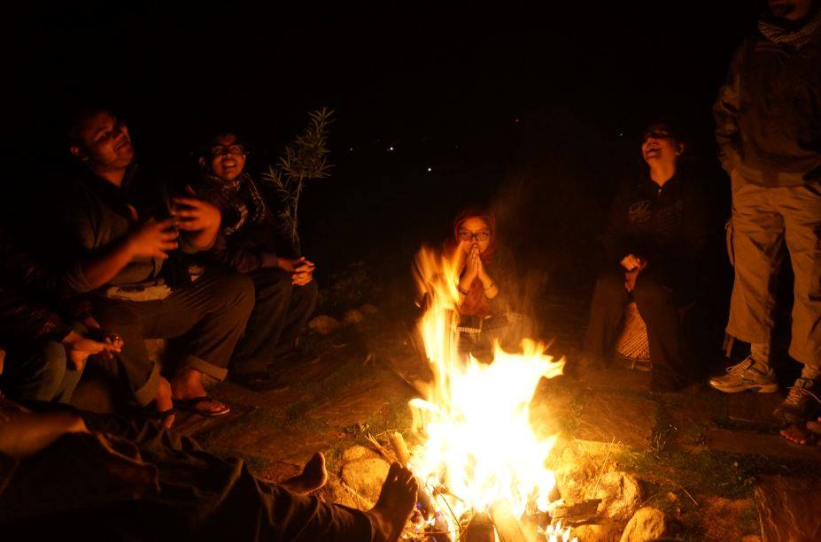](http://www.sambhaavnaa.org/wp-content/uploads/2014/02/1381302_10203552561843459_6644301777497071037_n.jpg)

The final night, although missing some members who left early, was spent singing and dancing around a bonfire into the late hours of the night. Many had planned to spend the next morning hiking up the mountain, but instead went and spent their time by the river.

[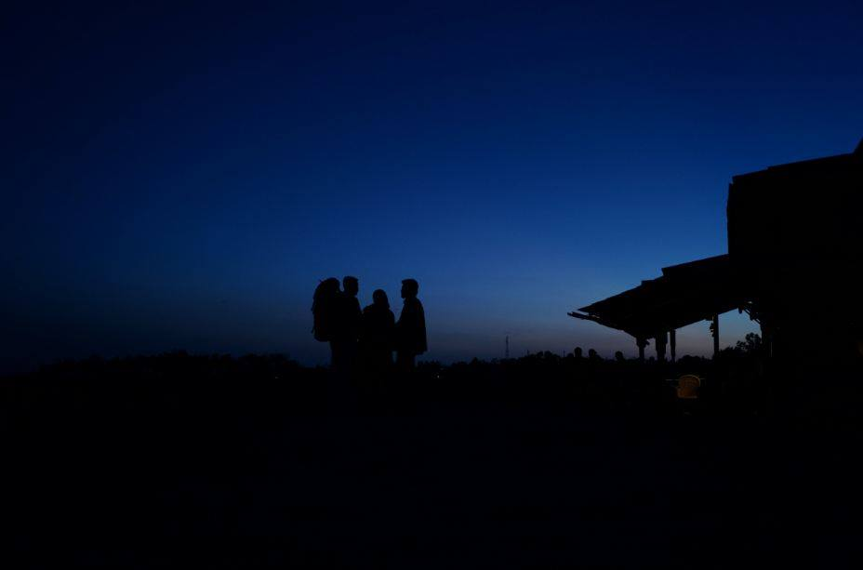](http://www.sambhaavnaa.org/wp-content/uploads/2014/02/10262071_10203552586964087_2766460145482186273_n.jpg)

Evenings were spent looking up at the stars.